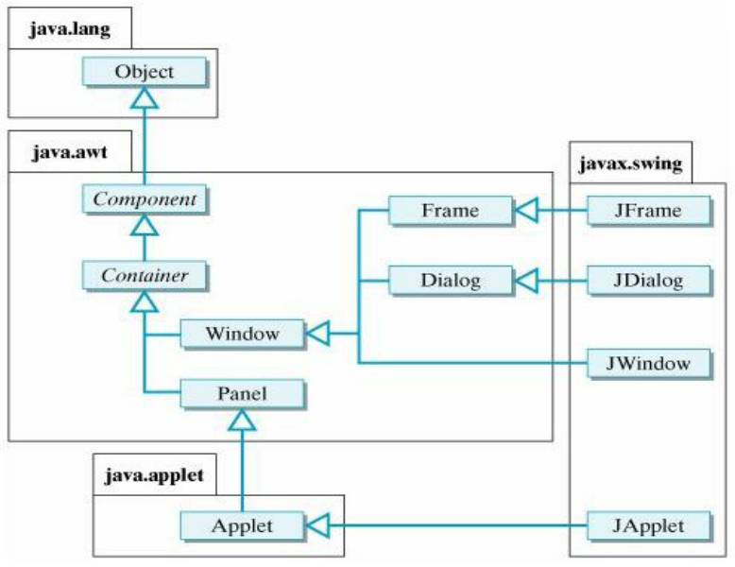
java.lang
Object
java.awt
Component
Frame
Container
Dialog
Window
Panel
KH
javax.swing
JFrame
JDialog
JWindow
java.applet
Applet
KH
JApplet

